EXECUTIVE SUMMARY

V-GUARD INDUSTRIES LTD – BIG IDEA TECH DESIGN COMPETITION 2026

Track: 4
Team Name: Codey Tingle
Team Members
1) Ayush Manoj Garg– 2027
2) Eshan Shukla - 2027
3) Tanay Chaplot - 2027

Institute/E-School: Mukesh Patel School of Technology, Management and Engineering, Mumbai

Mobile No of Team Lead: +91 99673 57298

E-mail ID of Team Lead: work.ayushgarg1@gmail.com

Number of words: 1480 Date of Submission: 12 August 2026
Google Drive Video Link
Please paste the google drive link of your team’s video pitch (40 seconds) below.
https://drive.google.com/file/d/1L5v3kpXAa7z1-tcZN7qO6fXomNGSpJg0/view?usp=sharing

Problem Statement (What & Why)
India's power is still unreliable – rural homes face 2–6 outages a week and the grid saw 68 major disturbances between 2022 and 2025. Home inverters/UPS are the lifeline, yet they – including today's “smart” models – remain reactive: they connect to an app but cannot predict, understand, or decide. So batteries die without warning (often mid-blackout), backup runs out because loads aren't managed, faults surface only after a breakdown, and users have no real grip on their energy use. For V-Guard – founded in 1977 to solve exactly this problem – the gap between “smart” (app-connected) and “intelligent” (self-aware) products is both the theme's challenge and the company's next natural mission. Closing it protects consumers and unlocks recurring, defensible revenue.
Brief Description of the Idea/Solution
V-Guard Intelligence puts a low-cost, on-device AI Core inside V-Guard products so each one predicts its own failures, learns its owner's habits, and acts autonomously – with the whole installed base improving together through privacy-preserving federated learning, all offline. The flagship is V-Guard Sentinel, an intelligence upgrade to the inverter/UPS + battery. Four on-device engines: (1) Predictive Health & Longevity – forecasts battery Remaining Useful Life (“safe until ~15 Nov”) and flags failing internals weeks early, extending battery life 15–30%; (2) Habit-Learning Autopilot – learns load/outage patterns and, during a blackout, autonomously protects critical loads (fridge, lights, Wi-Fi, medical) while shedding others to stretch backup 20–30%; (3) Energy Coach & Grid Shield – shows where power goes and predicts voltage sags; (4) Federated Fleet Intelligence – units share only encrypted model updates, never private data, so accuracy compounds with scale. The same AI Core then extends across pumps, stabilizers and water heaters – turning a portfolio of smart products into one intelligent, connected V-Guard home.
Technology Proposed
Sentinel runs on a compact AI Core (ARM Cortex-M-class MCU/NPU with sensor fusion) that reuses signals V-Guard already measures – current, voltage, temperature – plus a low-cost vibration/acoustic sensor. On-device models use TinyML (TensorFlow Lite Micro / Edge Impulse, 5–100 KB): coulomb-counting corrected by a TinyML model for battery State-of-Health/Remaining-Useful-Life (published accuracy ~85–95%); anomaly and current-signature models for component and pump faults (>96% in research); on-device clustering/forecasting for the autopilot; compact NILM for energy insights; and on-MCU FFT for voltage-event prediction. A federated-learning layer (Flower / TensorFlow Federated) syncs encrypted model updates opportunistically. Everything works with zero internet – critical for India's connectivity gaps – with cloud sync as a bonus. Added bill-of-materials cost is only ₹150–₹800 per unit (<10–15% premium), and V-Guard's installed base, in-house battery manufacturing and Kochi Innovation Campus provide the data and validation to build it now.

Supporting Detail — V-Guard Sentinel
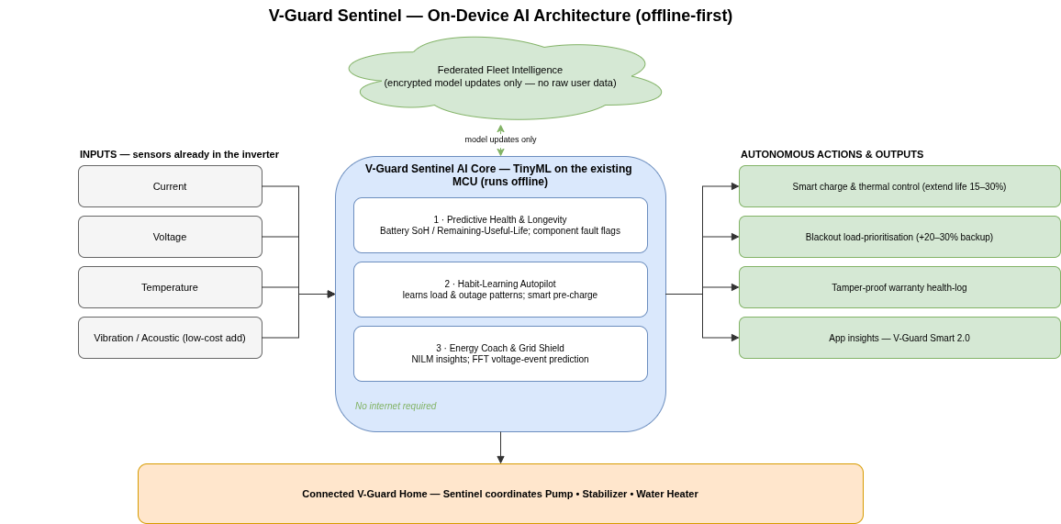
Figure 1. V-Guard Sentinel system architecture — the inverter's existing sensors feed on-device TinyML engines that drive autonomous actions; only encrypted model updates leave the home (federated learning). Runs fully offline.
Novelty & Innovation
Three capabilities in V-Guard Sentinel do not exist in the Indian market today. First, on-device predictive battery Remaining-Useful-Life for consumer power backup: competitors stop at reactive indicators – Luminous's “smart charging” and Havells's app monitoring report the present state; none forecast failure before it strands the user mid-blackout. Second, autonomous, offline blackout load-prioritisation: today's inverters merely trip on overload, whereas Sentinel decides what to keep alive, by itself, with no internet. Third, privacy-preserving federated learning across a consumer-appliance fleet – a modern-AI mechanism that turns V-Guard's installed-base scale into a compounding, un-copyable moat. The innovation is offline-first by design: where Western energy-AI players are cloud-dependent (and market leader Sense is exiting consumer hardware), Sentinel treats India's connectivity gaps as a design principle. Strategically, it reframes V-Guard – from the company that protects your appliances to the company whose products think.
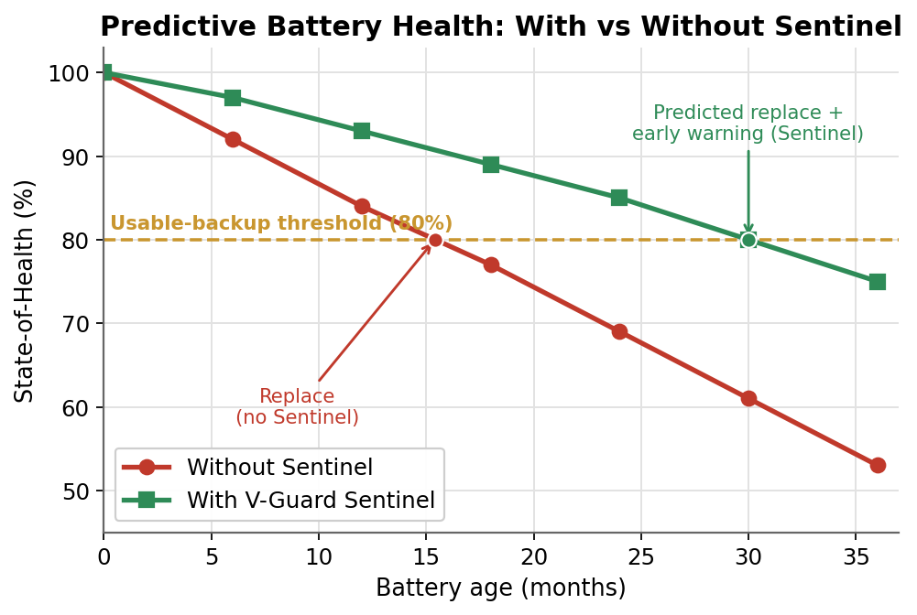
Figure 2. Predictive battery health (line-point comparison) — Sentinel keeps State-of-Health above the usable-backup threshold far longer, and forecasts the replacement window weeks in advance.
End-Consumer Value
Sentinel converts everyday anxiety into confidence. No more surprise battery death – the single biggest backup frustration is replaced by a weeks-ahead warning and 15–30% longer battery life. Longer, smarter backup – critical appliances stay powered 20–30% longer during outages, automatically, without buying a bigger battery. Lower bills and real awareness – the Energy Coach reveals waste and coaches savings, and roadmap features like predictive geyser preheating save 15–25% of heating energy. Effortless service – data-backed warranty claims and predictive service calls mean fewer breakdowns and no disputes. Privacy respected – personal usage never leaves the home. For a mass-market Indian household that depends on its inverter daily, these are tangible, felt benefits.
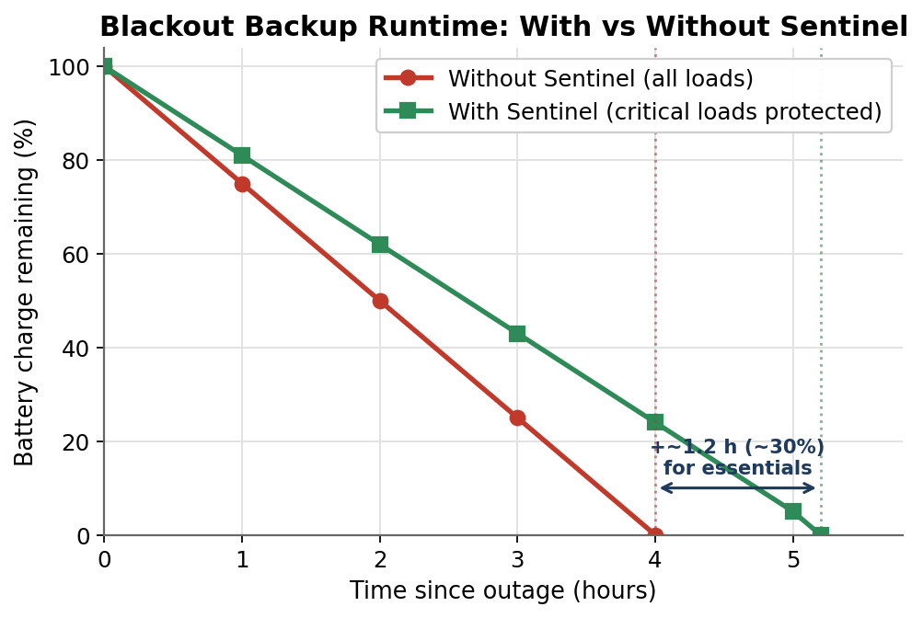
Figure 3. Blackout backup runtime (line-point comparison) — by protecting critical loads and shedding the rest, Sentinel extends usable backup for essentials during an outage.
Business Value — Why It Compounds for V-Guard
Sentinel is a profit-and-defensibility engine, not just a feature. Recurring, perfectly-timed aftermarket revenue: by predicting the replacement window, Sentinel prompts the customer to buy their next V-Guard battery from V-Guard, at the right moment – converting a one-time inverter sale into a managed lifecycle. Warranty and service cost reduction: predicting failures before they happen turns expensive emergency claims into planned, low-cost interventions – a direct margin lever on a ₹5,966-crore business. Retention and premiumisation: an intelligent, learning product commands a premium and locks customers into the V-Guard ecosystem. A data moat that grows with scale: through federated learning, every unit sold makes the product better and the moat deeper – an advantage Luminous and Havells cannot simply buy. Portfolio-wide leverage: one reusable AI Core extends to pumps (bearing-wear and dry-run prediction – V-Guard's largest, fastest-growing Electricals segment at ₹2,461 crore), stabilizers (voltage-event prediction – a large, ~7%-CAGR Indian AVR market), and water heaters (predictive preheating). The flagship funds a platform.
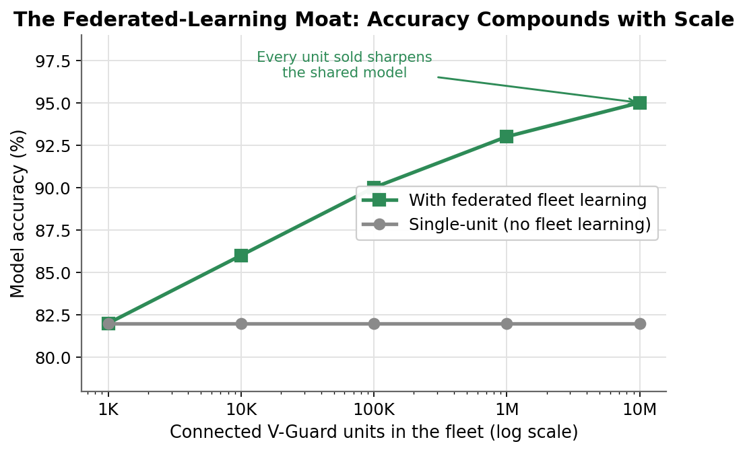
Figure 4. The federated-learning moat (line-point comparison) — model accuracy compounds as V-Guard's installed base grows; an advantage competitors cannot buy.
Competitive Differentiation
Against Luminous (reactive smart charging, cloud app), Havells (app monitoring, no prediction), Microtek/Su-Kam (price-led, minimal intelligence) and Western energy-AI (Sense/Emporia – cloud-dependent, premium, and exiting or absent in India), Sentinel is the only proposition that is simultaneously predictive, autonomous, offline-first, and self-improving through federated learning at mass-market cost.
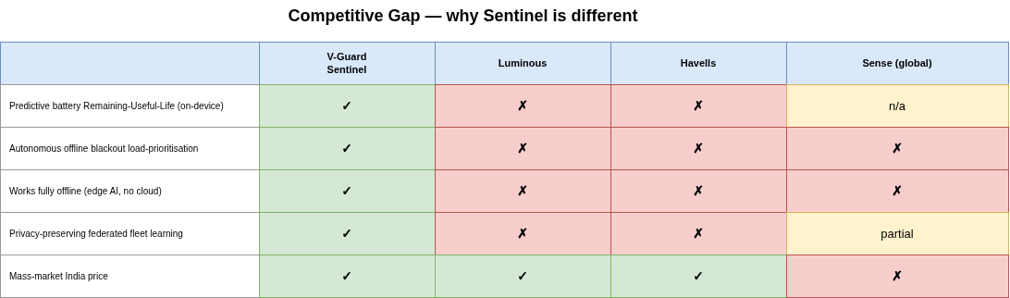
Figure 5. Competitive gap — Sentinel is the only offering that is predictive, autonomous, offline-first and self-improving at mass-market cost.
Technology Feasibility & Data Strategy
All models are proven and lightweight. Battery State-of-Health/RUL uses coulomb-counting corrected by a TinyML model (published accuracy ~85–95%), trained initially on public datasets (e.g. NASA randomized battery usage) and refined on V-Guard's own fleet duty-cycles. Fault detection uses anomaly and current-signature models (bearing-fault research exceeds 96% on the edge). The autopilot uses on-device clustering/forecasting; energy insights use compact NILM; grid protection uses on-MCU FFT. Federated learning (Flower / TensorFlow Federated) shares only encrypted model updates. We are deliberately honest about accuracy – Sentinel presents a warning window, not a false-precision failure date – which builds trust and avoids over-promising. Added BOM is ₹150–₹800 per unit; all core functions run offline.
Sustainability & Social Impact
Sentinel is inherently sustainable. Extending battery life 15–30% and predicting the exact replacement point reduces premature disposal of lead-acid and lithium batteries – a significant e-waste and lead-contamination burden in India. Optimised charging and load management cut wasted energy, and predictive maintenance extends product lifespans across the portfolio, reducing material consumption. For millions of price-sensitive and rural households, resilient, self-managing backup also improves quality of life – protecting food, study hours, connectivity and medical devices during the outages that remain a daily reality.
Market Opportunity
India's home-inverter/UPS and inverter-battery market is large and growing, driven by persistent outages, rising appliance ownership and electrification; the voltage-stabilizer (AVR) segment alone is a multi-thousand-crore market growing ~7% annually. V-Guard operates a ₹5,966-crore business across exactly these categories, with a national dealer network of 100,000+ touchpoints. Because Sentinel is a software-led upgrade to products V-Guard already sells at scale, the path from concept to revenue is short and the addressable base is enormous – every inverter, and eventually every pump, stabilizer and geyser, is a candidate.
Feasibility, Roadmap & V-Guard's Unfair Advantage
V-Guard already owns every hard piece: the installed base and fleet data to train models, in-house battery manufacturing to co-design health estimation, and the ₹120-crore Kochi Innovation Campus (IoT and reliability labs) to validate it. The rollout is staged and de-risked. Phase 1 (0–6 months): Sentinel battery-RUL and autopilot in the Smart Pro inverter line, with a federated-learning pilot. Phase 2 (6–18 months): Energy Coach and grid shield, plus the AI Core offered as a retrofit module for the existing base. Phase 3 (18–36 months): portfolio rollout across pumps, stabilizers and water heaters, coordinated as one intelligent V-Guard home.
Prototype Plan (Phase 3 Preview)
For the detailed round we will demonstrate: a trained battery-RUL model predicting a failure window from real battery-cycling data; a working federated-learning simulation across multiple “homes” that improves a shared model without sharing raw data; and an app that visualises health prediction and autonomous blackout load-prioritisation – with an optional low-cost edge-device demo running the quantised model on-hardware to prove true on-device inference.
Vision
By 2030, every V-Guard product in a home runs on one shared AI Core. The inverter, pump, stabiliser and water heater stop behaving as separate appliances and start operating as a single self-aware system that predicts its own failures, manages the home's power, and keeps essentials running through any outage, without the user ever thinking about it. The foundation already exists. V-Guard is a ₹5,989 crore business built on exactly these categories, sold through more than 100,000 retail touchpoints, with its Electronics segment, the home of this flagship, growing nearly 28% a year, the fastest in the company. Every unit shipped feeds the same models through federated learning, so scale itself becomes an advantage rivals cannot rebuild. V-Guard stops being the company that protects India's power and becomes the intelligence layer the Indian home runs on.

